3-D Printing activity text

Intro:
3-D Printing is the creation of a three-dimensional object from a digital 3-D model or a CAD (Computer-Aided Design) model.
3-D printing can broadly refer to several methods which create a physical object using computer control. This device can be programmed to deposit workable material (for example melted plastic) in flat, thin layers that join and gradually build up then harden.
The earlier stage of creating a digital 3-D model requires maths to get the correct measurements of the original object. Many professionals use a scanner to collect information, this can also include details about the objects surface for example the texture and/or colour.

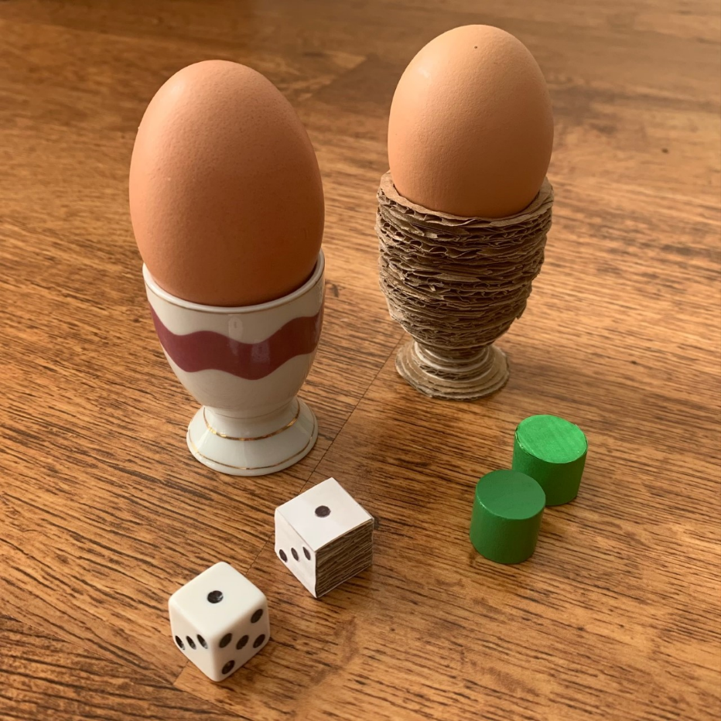
Activity:
In this activity, we used mathematical tools, such as rulers and protractors, to gather information about the object we wanted to recreate as a 3-D model. We made a note of the object's length and width – for more advance models we calculated the circumference too. Once we had all the information we required, we used cardboard to replicate the 3-D printer process. To finish, we used paper and colouring pens to add a render - a visual representation of what the surface looked like. If you would like to try out this activity, follow the steps below.

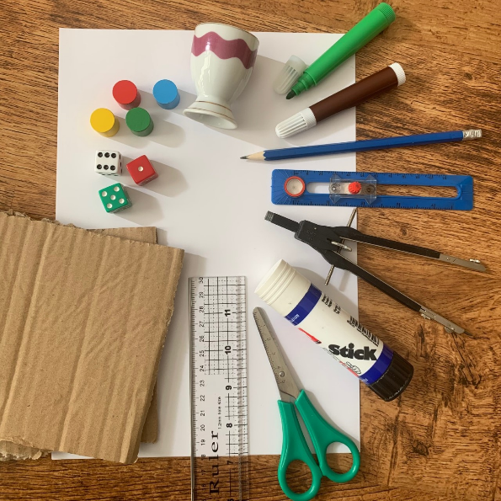
What you will need:
Objects – to start off we opted for game pieces such as dice and counters, for a more advance remake we chose an egg cup. *Remember, the larger the object the longer it will take to build!
Ruler and a compass – to measure and assist when drawing
Pencil – to take note of object measurements
Paper – to record measurements and to apply a surface render
Cardboard – to build our 3-D object in layers
Scissors – to cut the cardboard and paper
Glue – to stick together the layers of cardboard and the paper surface render
Pens – to add detail to the finished surface

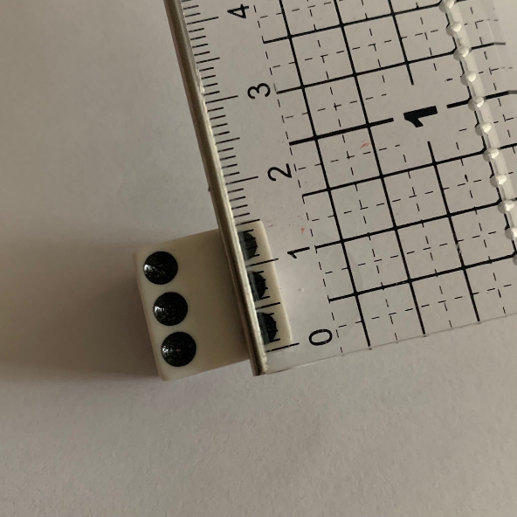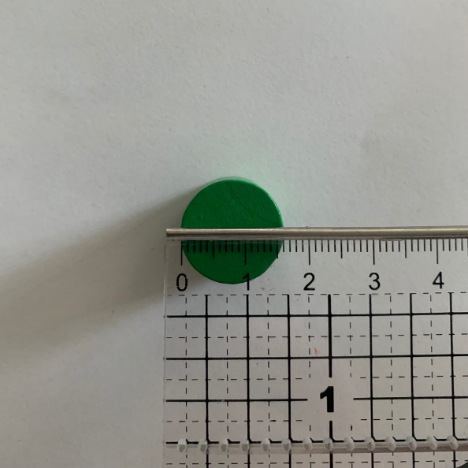

Step 1 (Option A)
Using the ruler, measure and take note of the object's length and width.
If the object is cylindrical, measure the diameter and half this to get the radius – you will need this information later when using the compass.

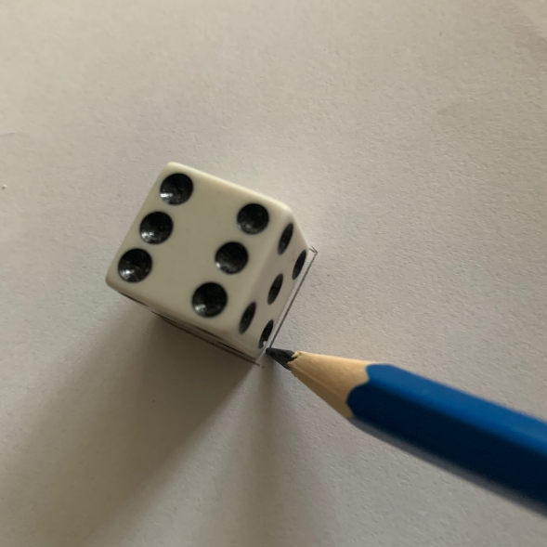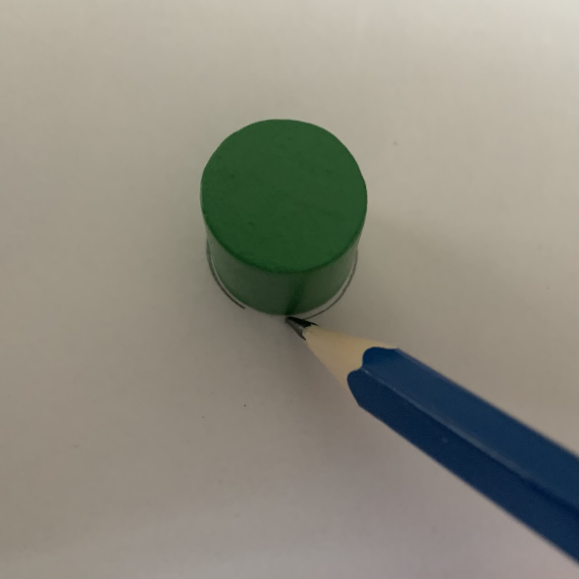
Step 1 (Option B)
If this step is too advanced, simply trace around the object and create a template.

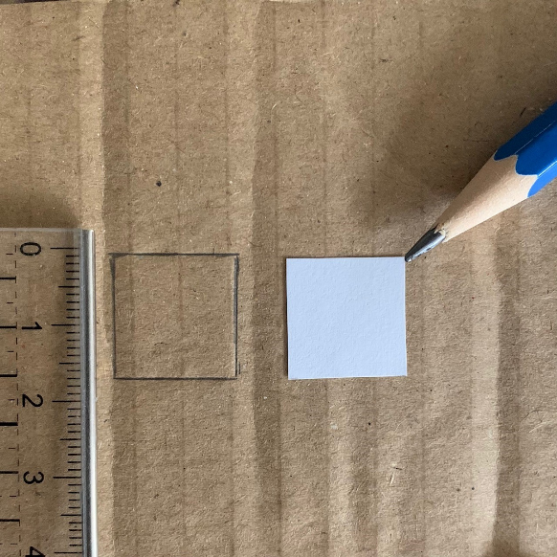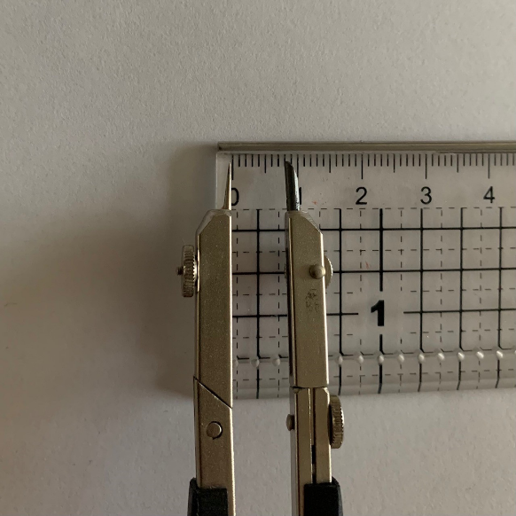
Step 2
Transfer these measurements on to the cardboard. Use the pencil, ruler, and recorded measurements to help you do this or use the template option.
If it is a cylindrical shape, set your compass to the radius measurement, do this by placing the compass next to the ruler and adjust the compass until correct.

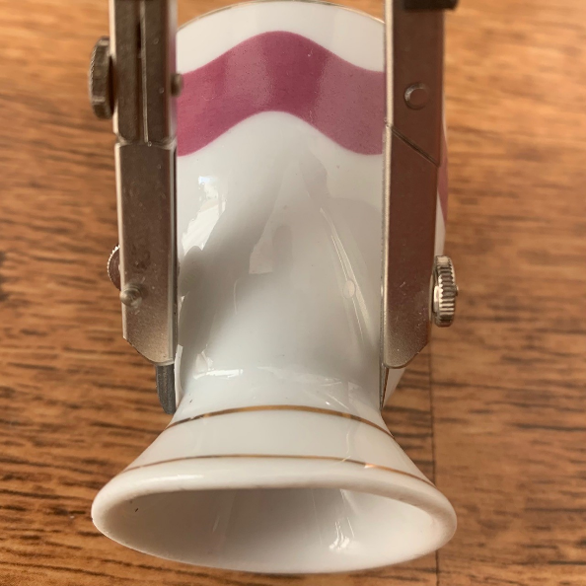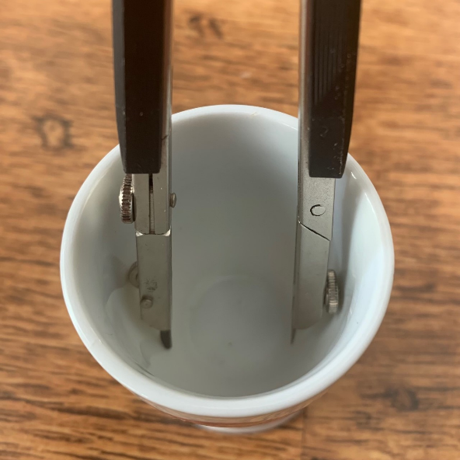
Top Tip!
If completing a more advance build, such as an egg cup, use the compass to help you gather measurements in tricky areas.
Do this by placing the compass across the area you wish to measure and adjust the compass until it lines up with object’s edges. Then, place the compass next to the ruler to take note of the dimension it equates to.
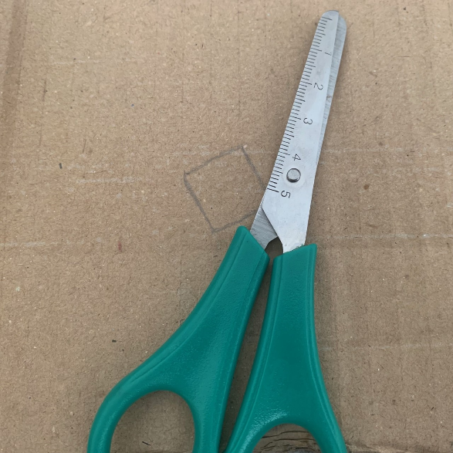
Step 3
Draw out the shape serval times (enough to get you started) then carefully cut around the shapes.
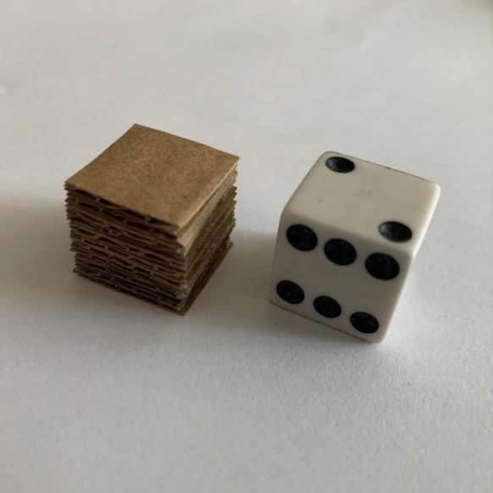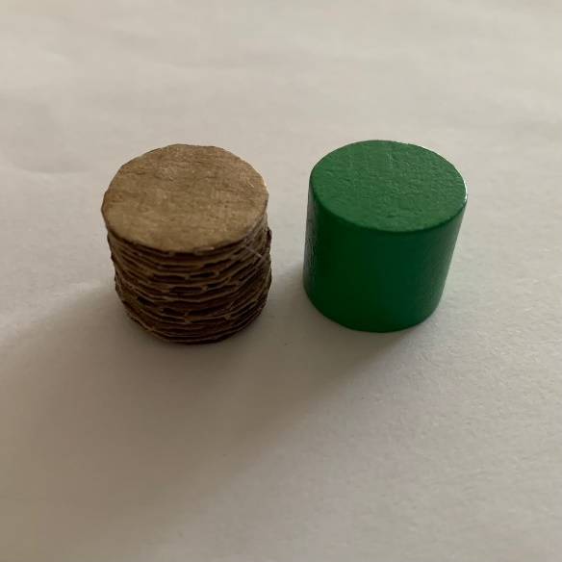
Step 4
Stack the cardboard shapes until it matches the objects height. When ready, glue all the cardboard layers together.

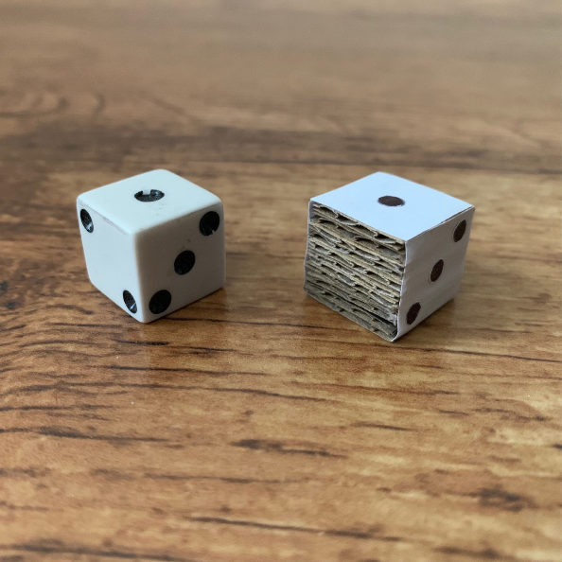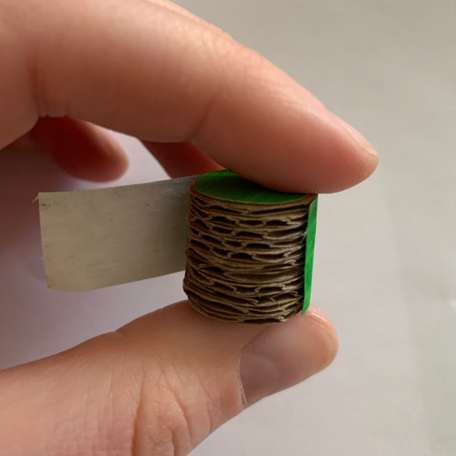
Step 5
Render the surface of the cardboard. We did this by repeating Step 3 – using paper instead, then attached it to the 3-D cardboard model using glue. To finish, we used colouring pens to decorate the surface.

