Think Stats: Teacher Guide
Designed for learners in Primary 6/7

Activity Summary
The Think Stats activity get learners thinking about how information is collected and introduces some simple approaches to visualise the data that they have collected. You will be provided with access to a data collection application, where students will answer some questions about themselves. They will then be introduced to bar charts, dot plots and pie charts. This means that they can get creative and produce their own data visualisations that will tell them about their class’s responses to our survey…most importantly who doesn’t like Irn-Bru?!

Guidance

Introduction
The first step of this activity is to introduce your students to what statistics actually is and why we are interested in it. We have produced a video for this part which can be found at the following link:
https://www.youtube.com/watch?v=hs4gpdhC1JE
Please feel free to do this yourself if you would prefer.
Then you should try to get your students to think about ways that information can be collected. Answers like “from books”, “from the internet” “the news” etc are all really good and these are definitely ways that researchers will collect certain piece of information, but what if we want to collect information about people that can’t be found in a book or online? We ask them. Statisticians use surveys as one way to collect information for their research. We want the learners to find out more about each other so we have a survey for them to fill out.
We have provided an app that will collect the survey information from students to allow for the possibility that schools are not fully returned, however if you prefer you can collect this information in class by just asking for a show of hands for each option.
Note that if you do choose to use the app, we do not collect any personal information, and will delete the data collected after 1 month of you holding your event (unless you tell us otherwise). We will provide you with a code to access the app and will store all data in a dropbox account for security.

The app
The app can be accessed at the following URL:
https://katepyper.shinyapps.io/RSSOutreach/
You will be asked to enter a username and password. If you do not have one, please contact kate.pyper@strath.ac.uk. This will identify your class, so you should not use a username and password that is not yours. If you are asking students to fill out the survey at home you will need to supply them with the log in details. Alternatively you can set this up on a school computer and ask pupils to fill this in over an extended period of time. There are three tabs in the app.

1. Survey
This is where the students input their responses to the survey.
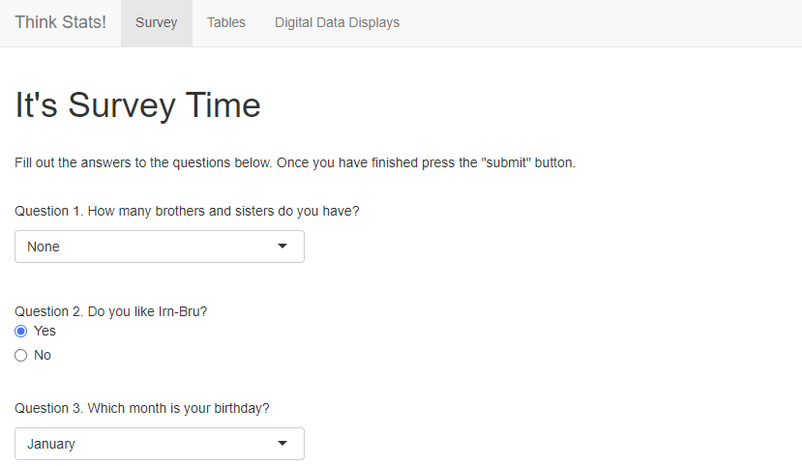
Learners will input their responses by either selecting from a drop down list (Question 1) or by clicking on a button (Question 2)
The other tabs should only be accessed once all students have completed the survey. At this point you can ask if any students found it hard to fill in any parts of the survey? We limited the options for the favourite colour and favourite hobby questions so there should be at least one who couldn’t answer (and if done in class they might even point this out while they’re filling the survey in). If yes talk about including an “other” option that allows people to input their own answer so that no-one is left out.

2. Tables
Once everyone has completed the survey you should access this tab. This will provide data summaries for the students to produce their plots.
When showing the students this feel free to point out that tables provide all of the information but there are more visually interesting ways to display the data and that it is their job to show this data in a more interesting way.
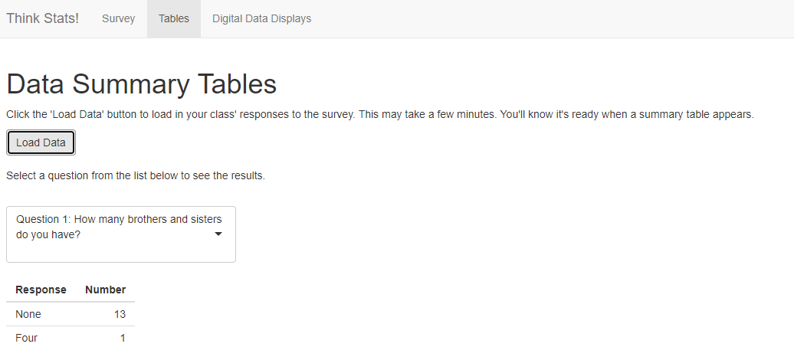
Select a question from the drop down list to show the table for that question
When opening the app you will need to click this button to load in the data for your class
If able to work in groups:
Each group of students should be assigned a survey question and can choose one of the charts or graphs to use. Their task is to create a poster of the results for their question. Learners could be asked to share their poster in class or on their home learning platform.
If not able to work in groups:
Each student should be assigned a survey question and one of the charts or graphs to use. Their task is to create a poster of the results for their question and plot. Learners could be asked to share their poster in class or on their home learning platform.
We have produced a video that describes different charts, graphs and diagrams, which can be found at the following link:
https://www.youtube.com/watch?v=vsOyjtlKVgs
Again, please feel free to cover this material yourself if you would prefer.

3. Digital Data Displays
Once learners have created their posters, show them how statisticians would display their data in practice using digital technology.
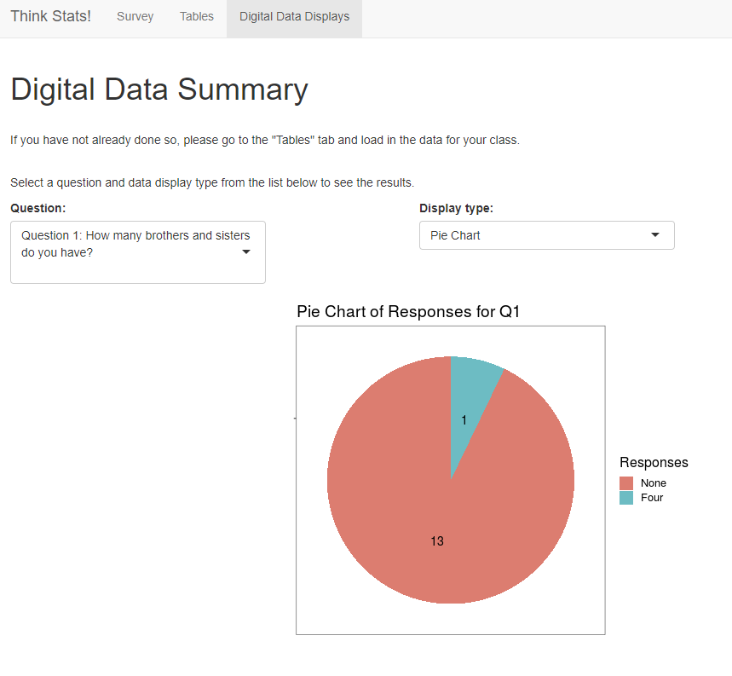
Select the chart type here
Select the relevant question here

The conclusion
We have produced a video talking about other cool visualisations that have been created. This is available at the following link:
https://www.youtube.com/watch?v=u45R2Ol7lIE
Hans Rosling was a legend in data visualization. The video linked below is old (2009) but shows an amazing and unusual application of data visualization. Definitely worth a watch!
https://www.youtube.com/watch?v=jbkSRLYSojo&ab_channel=BBC
We then like to hear the learners talk about what they’ve learned and what they think about statistics. Please share these with us on twitter @RSSGlagow1!

